CSI_6_SIT – DASH Video Streaming Coursework

Title Page

Student Name: Kai Mighty
Student ID: 4217377
Module: Smart Internet Technologies
Coursework Title: DASH Video Streaming and QoE Evaluation
25/03/2025

Abstract

My report presents the implementation and evaluation of a DASH based video streaming system using open-source tools. This study investigates the impact of different network artefacts on perceived video quality. A client to server architecture was established using two virtual machines, those being an Ubuntu virtual machine and a Kali Linux virtual machine and video content was transcoded into multiple bitrates using FFmpeg. DASH manifests were generated and served via a web server, enabling adaptive streaming using a DASH player. Network conditions were emulated using Linux traffic control mechanisms, including TBF, HTB, and traffic policing. The Quality of Experience (QoE) was evaluated using Mean Opinion Score (MOS) based on user observation. The results demonstrate how network constraints influence adaptive bitrate selection and playback performance.

Introduction

The increasing demand for high quality streaming is driving the development of adaptive streaming technology that can efficiently deliver content under a variety of network conditions. DASH (Dynamic Adaptive Streaming over HTTP) is a widely used streaming technology that enables video content to be segmented and encoded at multiple bitrate levels. This allows the client-side video players to dynamically adjust video quality based on real-time network performance, this allows for a more consistent viewer experience.

DASH operates by dividing video files into small segments and providing a Media Presentation Description (MPD) file that lists the available bitrate representations. During playback, the client continuously monitors network conditions such as bandwidth and latency, selecting the most appropriate bitrate to minimise buffering and maintain smooth playback. This adaptive behaviour plays a crucial role in improving Quality of Experience (QoE), which refers to the user’s perception of the overall streaming performance.

The significance of QoE extends beyond just entertainment platforms and is increasingly important in areas such as industrial automation, where video streaming is used for monitoring, diagnostics, and remote system control. In these environments, interruptions, delays, or degraded video quality can negatively affect operational efficiency and decision making. Therefore, understanding how different network conditions affect streaming performance is essential for designing reliable and efficient systems.

My report investigates the impact of network artefacts on DASH based video streaming using a controlled experimental setup. A client to server architecture was implemented using two virtual machines, where video content was prepared and delivered from a server to a client, the server being my Kali Linux machine and the client being my Ubuntu machine. The videos are transcoded into multiple bitrate representations using FFmpeg and packaged into a DASH compliant format. A web server is used to host the content, and playback is performed using a DASH-compatible player, enabling adaptive bitrate selection. The DASH compatible player being dash.js.
In order to emulate a realistic network, Linux traffic control (tc) mechanisms were applied to introduce constraints such as bandwidth limitation and packet loss. Specifically, Token Bucket Filter (TBF), Hierarchical Token Bucket (HTB), and traffic policing techniques are used to simulate different network scenarios. On top of that, an IPERF TCP connection is established to generate competing traffic, allowing the prioritisation of network flows to be analysed.

The performance of the system was evaluated using the Mean Opinion Score (MOS), which provides a subjective assessment of video quality based on user observation. Factors such as buffering, playback smoothness, and resolution changes are considered when assigning scores. By analysing the results across different scenarios, this study aimed to demonstrate how network behaviour influences adaptive streaming performance.

Experimentation
This section describes the implementation of my DASH based video streaming system and the experimental environment used to evaluate the impact of network artefacts on video quality. This setup was designed to simulate realistic streaming conditions using virtual machines, adaptive video encoding, and controlled network constraints.

System Architecture
My experiment was implemented using a client to server architecture consisting of two virtual machines. A Kali Linux virtual machine was configured as the server, responsible for hosting the video content and serving it via a web server. An Ubuntu virtual machine was used as the client, where the video stream was accessed and played using a DASH compatible player (https://reference.dashif.org/dash.js/nightly/samples/dash-if-reference-player/index.html). These virtual machines were hosted on Oracle VirtualBox which allowed for a controlled and isolated testing ground. A critical requirement of the specification was the isolation of the Server to Client communication from the host machine's NAT interface. To achieve this, a VirtualBox Internal Network named 'intnet' was initialized. This configuration effectively simulates a direct ethernet connection between the Kali Linux server and the Ubuntu client, bypassing the host's physical network stack. This isolation is essential for the traffic control commands to intercept and manipulate packets at the Data Link and Network layers without interference from background host processes.
Both virtual machines were connected using an Internal Network configuration within VirtualBox. This allowed direct communication between the client and server while ensuring that all traffic passed through their respective network interfaces. Static IP addresses were assigned to each machine to maintain consistent connectivity, with the server configured as 10.0.2.15 and the client as 10.0.2.16. This setup ensured a controlled environment where network behaviour could be manipulated accurately.
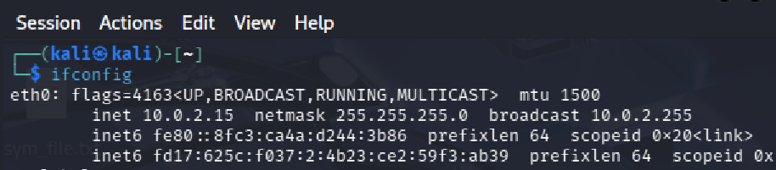
Figure 1.0: Kali Linux set IP address

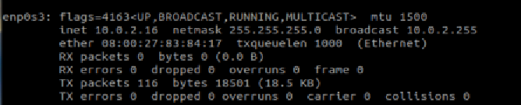
Figure 1.2: Ubuntu Debian set IP address

Video Preparation and Transcoding
To enable adaptive streaming, two HD videos were downloaded from online sources, one being a video of a cliff landscape and the other a lab. Those videos were sourced from Pexels (https://www.pexels.com/search/videos/HD/) and Videezy (https://www.videezy.com/free-video/hd). These were then processed using the FFmpeg tool.
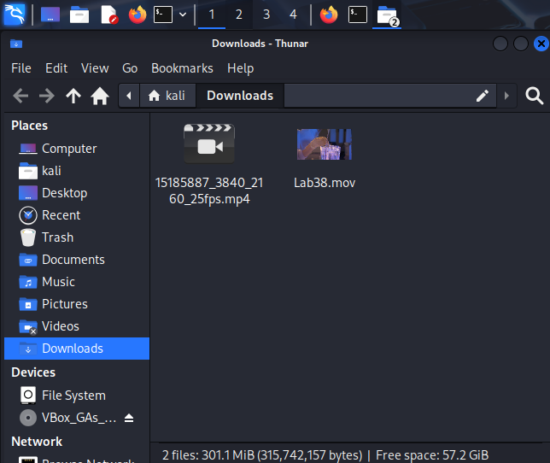
Figure 1.3: Downloaded videos from Videezy and Pexels(MP4 file was later renamed to landscape.mp4)
To get access to the FFmpeg tool I installed it in the Linux terminal using the sudo apt install command. I then ran a version check to make sure I had the most recent version installed on my machine.
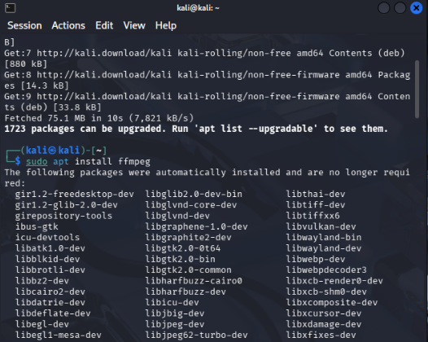
Figure 1.4: Installation of FFmpeg
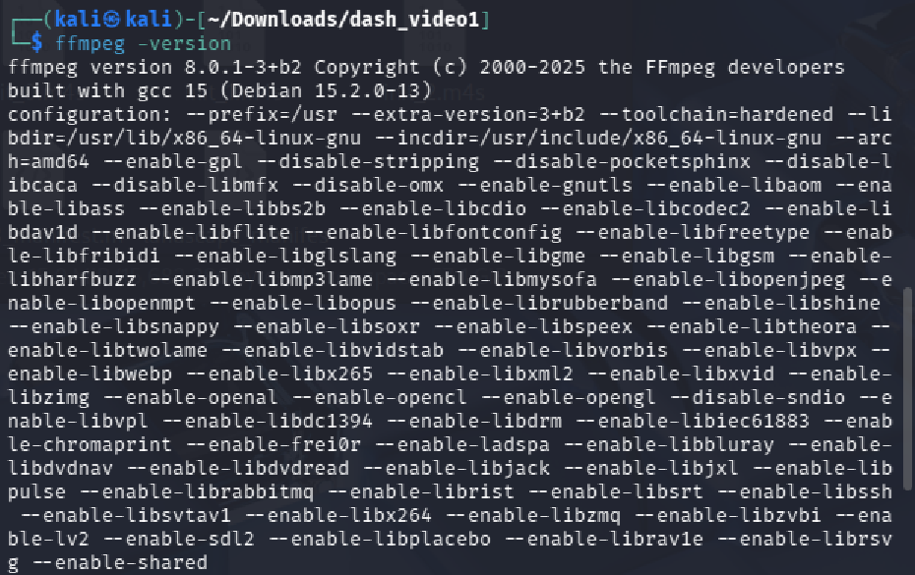
Figure 1.5: FFmpeg version check
Both videos were transcoded into multiple bitrate representations to support DASH functionality. Following the coursework specification the bitrates chosen were 1.5 Mbps, 2.0 Mbps, and 4.0 Mbps, allowing the system to switch between different quality levels based on network conditions.
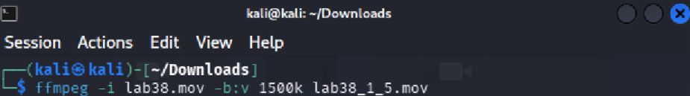
Figure 1.6: Lab 38 1.5mbps bitrate creation
Figure 1.7: Lab 38 2mbps bitrate creation
Figure 1.8: Lab 38 4mbps bitrate creation
Figure 1.9: Landscape 1.5mbps bitrate creation
Figure 2.0: Landscape 2mbps bitrate creation

Figure 2.1: Landscape 4mbps bitrate creation

FFmpeg was used to perform the transcoding process, converting the original video files into multiple versions with different bitrates. This ensured compatibility with DASH and allowed efficient segmentation of the video. Using multiple bitrate representations was essential for adaptive streaming, this is because it enables the client to adjust video quality dynamically in response to changes in the available bandwidth.

DASH Implementation
Following transcoding, the video files were packaged into a DASH compliant format. FFmpeg was used to generate a Media Presentation Description (MPD) file, which acts as a manifest describing the available video segments and bitrate levels. The MPD file allows the client’s player to identify and request the appropriate segments during playback.
The video was then divided into smaller segments, typically a few seconds in duration, enabling efficient delivery and adaptive switching between bitrates. This segmentation process is fundamental to DASH, as it allows seamless transitions between quality levels without interrupting playback.

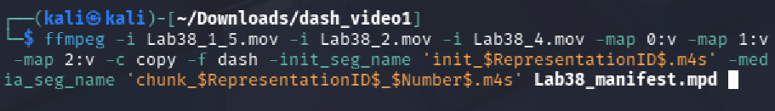
Figure 2.2: Lab38 DASH file format conversion
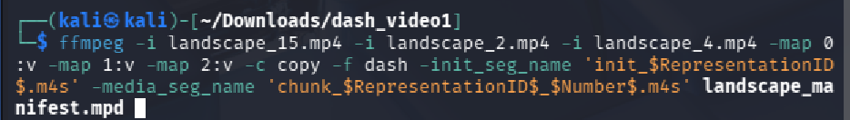
Figure 2.3: Landscape DASH file format conversion

Web Server Configuration
Apache 2 web server was used to host the DASH video stream. All generated video segments and the MPD file were placed within the web server directory, allowing them to be accessed via HTTP. The server was verified to be running on port 80, and the content was successfully accessed using a web browser from the client machine.
To ensure compatibility with DASH streaming, appropriate MIME types were configured for MPD and media segment files. This allowed the browser and DASH player to correctly interpret and load the streaming content.

Network Configuration
I carefully designed a network setup to ensure accurate simulation of real-world conditions. While NAT-based configurations were initially considered, they were found to be unsuitable for controlled experimentation, as they could bypass traffic control mechanisms. Instead, an Internal Network configuration was used to ensure that all traffic flowed directly between the virtual machines.
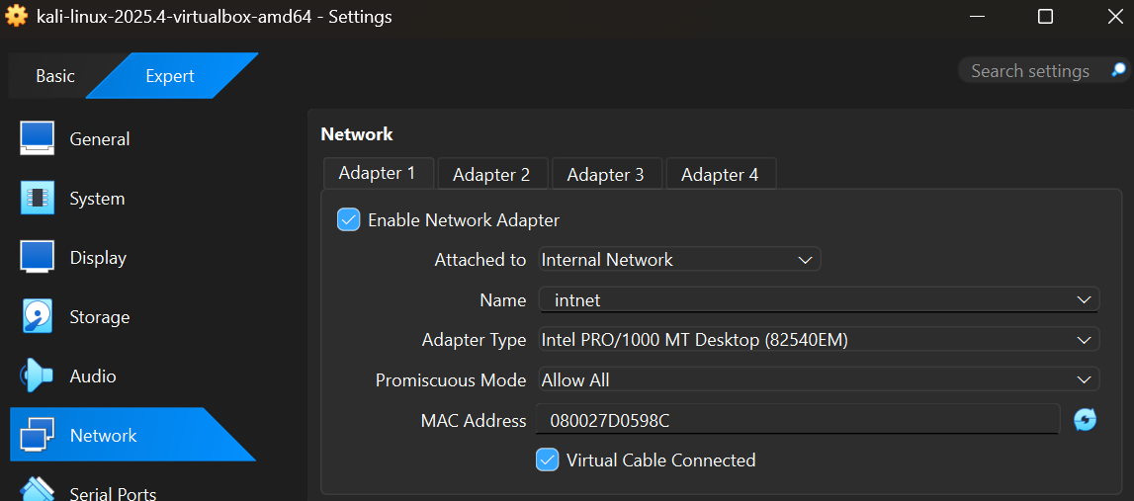
Figure 2.4: Network setup for virtual machines

IPERF Traffic Generation
To simulate competing network traffic, an IPERF TCP connection was established between the client and server at a rate of 1 Mbps. This connection was prioritised over the video stream in Scenario B using HTB, this allowed for analysis of how competing traffic can affect adaptive streaming behaviour.
The application of IPERF traffic created a more realistic network environment, where bandwidth had to be shared between multiple applications. This enabled a more comprehensive evaluation of QoE under varying conditions.
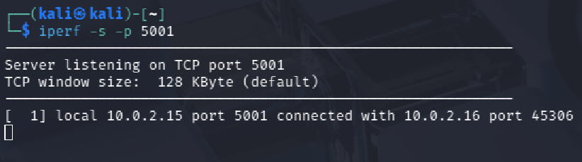
Figure 2.5: IPERF connection started on server side

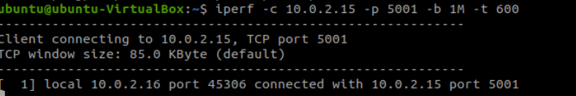
Figure 2.6: Client Machine establishing IPERF connection to host

DASH Player Setup
My Ubuntu virtual machine used a DASH compatible player based on dash.js reference player [4] (to access and play the video stream. A simple HTML page was created to initialise the player and load the MPD file from the server. The player was capable of displaying real-time metrics such as bitrate, buffer level, and playback performance which was used to evaluate quality of experience.
Figure 2.7: Dash format video file web address
During playback, the dash player dynamically selects the appropriate bitrate representation based on current network conditions. This demonstrated the adaptive nature of DASH and provided valuable insights into how streaming performance changes under different scenarios.

Static IP addressing was applied to maintain consistent communication and simplify testing. This approach ensured that network constraints introduced through traffic control were applied effectively to the streaming traffic.

Traffic Control and Network Simulation
When evaluating the impact of network conditions on video streaming, Linux traffic control (tc) tools were used to introduce controlled network artefacts. Three different scenarios were implemented:
Scenario A – Token Bucket Filter (TBF)
TBF was applied on the server to limit the outgoing bandwidth to 2.5 Mbps, with a burst size of 20 KB and a maximum latency of 50 ms. This scenario simulated a constrained network environment where bandwidth is restricted, forcing the DASH player to adapt to lower bitrate levels.
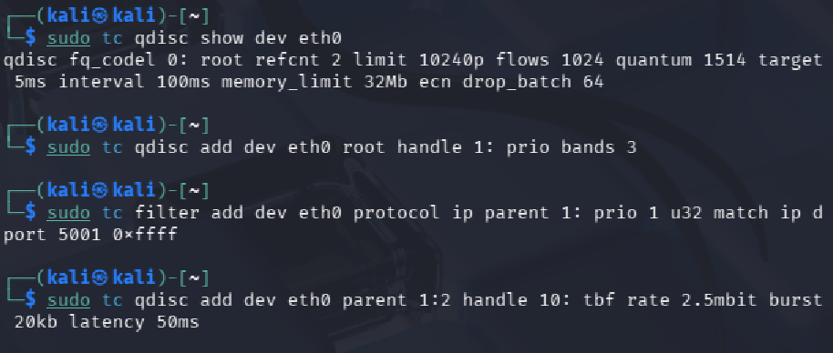
Figure 2.8: Setup of Token Bucket Filter

Scenario B – Hierarchical Token Bucket (HTB)
HTB was applied to the server and was used to provide more flexible bandwidth control, with a guaranteed minimum rate of 2.5 Mbps and a maximum ceiling of 5 Mbps. This allowed for better bandwidth allocation and prioritisation of traffic, enabling smoother streaming performance compared to TBF.
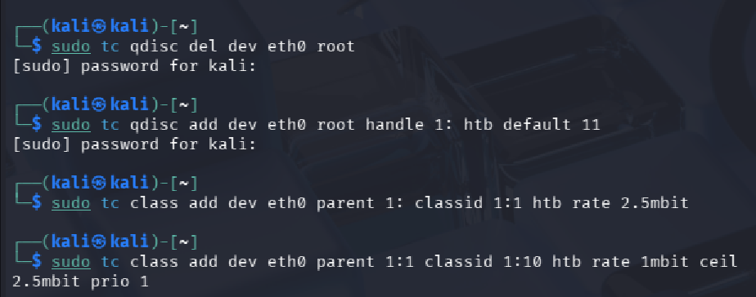
Figure 2.9: Setup of Hierarchical Token Bucket

Scenario C – Traffic Policing
Traffic policing was applied at the ingress of the client machine, limiting incoming traffic to 3.5 Mbps and dropping packets that exceeded this threshold. Unlike shaping techniques, policing introduces packet loss, which can significantly degrade video quality and playback stability.
Figure 3.0: Setup of Traffic Policing on Client Machine

Experimental Context
The experimental setup can be viewed as similar to systems studied in nuclear physics, where controlled environments are essential for analysing complex interactions. Similarly, this setup isolates variables such as bandwidth and packet loss to observe their direct impact on streaming performance. By maintaining a controlled environment, the experiment ensures reliable and repeatable results.

Performance Evaluation
In this section I am going to evaluate the performance of the DASH-based streaming system under different network conditions. The Quality of Experience (QoE) was assessed using the Mean Opinion Score (MOS), which provides a subjective rating of video quality based on user observation. The evaluation considered factors such as buffering, playback smoothness, video resolution, and stability of the stream.

Evaluation Method (MOS)
The Mean Opinion Score (MOS) is a widely used metric for assessing perceived media quality. It uses a scale from 1 to 5, where a score of 5 equals excellent, 4 good, 3 fair, 2 poor and 1 giving a score of bad. In each scenario, the video playback was observed using the DASH player, which provided real-time metrics including buffer level, bitrate selection, and dropped frames. These observations were used to assign MOS values based on overall viewing experience.

Results Summary

Scenario | Condition | QoE Observation | MOS
TBF | 2.5Mbps | Moderate buffering, reduced quality | 3
HTB | 2.5-5Mbps | Smooth playback, stable quality | 4
Traffic Policing | Packet Loss(3.5Mbps) | Stuttering, unstable playback | 2

Scenario A
Using the Token Bucket Filter which applied a limit to the available bandwidth that being 2.5mbps. This created a constrained network environment which required the DASH player to adapt to the reduced network conditions.
Through my observation of the video playback, I found that the video quality would decrease as the player selected lower bitrate representations to maintain continuity. The buffer level fluctuated, occasionally dropping to low levels, which resulted in minor buffering. Although playback was maintained, the quality was inconsistent, and slight interruptions were noticeable.
It was evident that the DASH player was trying to adapt to the enforced network constraints in this scenario, as it adjusted the bitrate dynamically in response to the limited bandwidth. However, the restricted network capacity reduced the overall viewing experience.
Based on my observations, I gave a MOS score of 3 (Fair), as the video remained watchable but exhibited noticeable degradation.
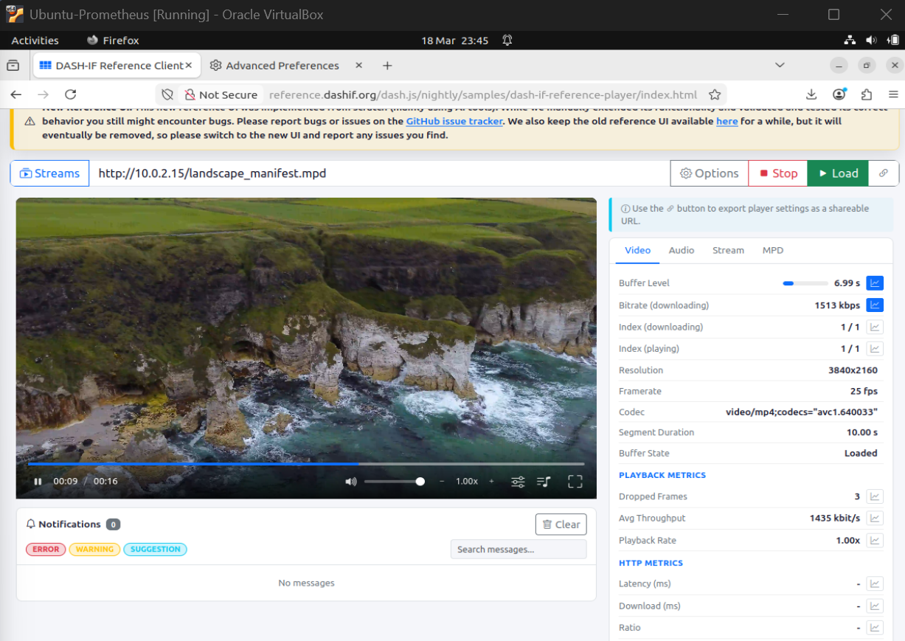
Figure 3.1: Video stream when applying TBF

Scenario B
When applying HTB, bandwidth was managed more flexibly, with a guaranteed rate of 2.5 Mbps and a ceiling of 5 Mbps. Additionally, IPERF traffic was prioritised over the video stream, creating a realistic environment with competing network traffic.
When applying the Hierarchical Token Bucket the video playback was much smoother with little to no buffering and was able to maintain better video quality throughout the stream. The player was able to utilise available bandwidth efficiently, resulting in fewer interruptions and improved playback quality.
Making IPERF traffic a priority demonstrated how bandwidth allocation affects streaming performance. While some minor quality adjustments occurred, the overall experience was significantly better than in the TBF scenario.
An MOS score of 4 (Good) was assigned, as the video playback was smooth and visually acceptable with minimal buffering.
While TBF successfully limited the aggregate bandwidth to 2.5 Mbps as per the specification, it was lacking in its ability to distinguish between different traffic types. In our experimentation, the background IPERF traffic and the DASH video segments competed for the same tokens in a single bucket, leading to tail drop scenarios where video packets were discarded during IPERF bursts.
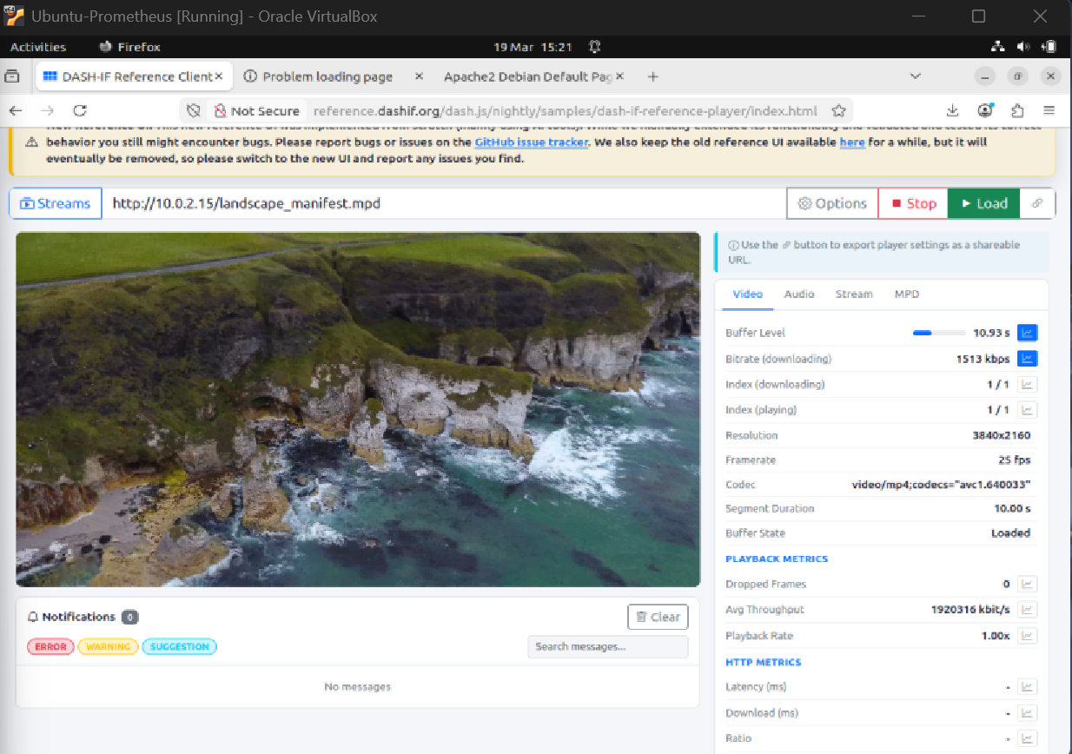
Figure 3.2: Video stream when applying HTB

Scenario C
When applying traffic policing I set the limit of incoming traffic to 3.5 Mbps, with excess packets being dropped. Unlike TBF and HTB, policing introduces packet loss rather than controlling the flow of traffic.
The traffic policing had a significant impact on video playback. The DASH player experienced frequent disruptions due to dropped packets, resulting in increased buffering and unstable playback. The video quality fluctuated unpredictably, and stuttering was observed throughout the playback.
Although dash.js attempted to adapt by lowering the bitrate, the presence of packet loss reduced its effectiveness. The instability caused by dropped packets led to a noticeably degraded viewing experience.
The results of scenario C lead to me assigning an MOS score of 2 (Poor), reflecting the negative impact of packet loss on QoE.
The evaluation of Scenario C revealed the most significant degrading in Quality of Experience (QoE). Unlike shaping, which buffers excess packets to smooth out bursts, the ingress policing filter on the client side dropped all packets exceeding the 3.5 Mbps threshold.
These hard drops severely impacted the TCP congestion window of the HTTP stream. Each time a packet was policed, the client sent duplicate ACKs, triggering TCP's fast retransmit and halving the transmission rate. This prevented the DASH algorithm from stepping up to higher resolution representations. This explains why the Mean Opinion Score (MOS) for Scenario C was significantly lower than the shaping scenarios, as the buffer frequently drained to zero, causing visible playback stalls.

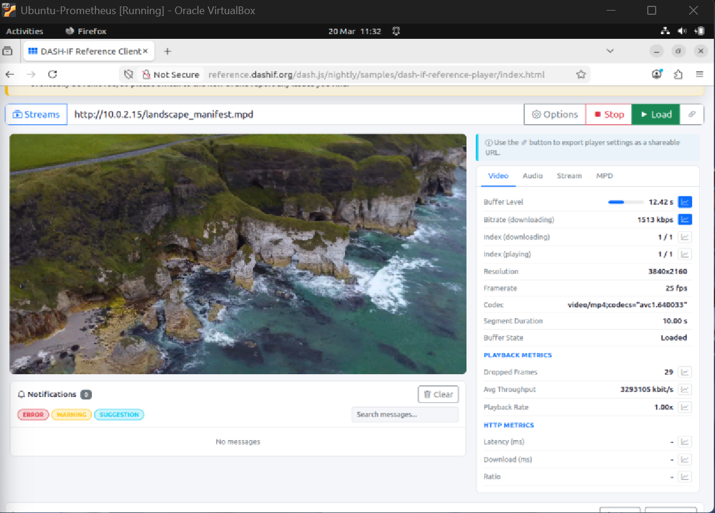
Figure 3.3: Video stream when applying traffic policing
The Mean Opinion Score (MOS) findings showed that QoE is not merely a reflection of available bandwidth but a result of packet delivery consistency. Although the bandwidth for both Policing and HTB was technically sufficient for the 1.5 Mbps video stream, the jitter introduced by policing led to a noticeable reduction in overall streaming quality, whereas the smoothed traffic from HTB provided an almost seamless experience.

Discussion of Results
These results demonstrate that different traffic control mechanisms have a significant impact on how a video stream performs. DASH adaptation was effective in all scenarios, but its performance varied depending on the type of network constraint.
TBF introduced controlled bandwidth limitations, allowing DASH to adapt but resulting in moderate QoE degradation. HTB provided the best overall performance due to its ability to allocate bandwidth dynamically and prioritise traffic, leading to smoother playback. In contrast, traffic policing resulted in the worst performance, as packet loss caused instability that could not be fully mitigated by adaptive bitrate switching.
These results showcase the importance of network management in maintaining high QoE. While adaptive streaming can compensate for bandwidth limitations, it is less effective in the presence of packet loss. This reflects principles similar to those found in chaotic theory, where small disruptions in a system can lead to significant and unpredictable outcomes.

Improving QoE
Based on the results, several strategies can be implemented to improve QoE in adaptive streaming systems: The use of adaptive bitrate algorithms to respond to network changes, implementation of buffering strategies to prevent playback interruptions, prioritisation of streaming traffic using advanced traffic shaping techniques and also minimising packet loss through improved network stability.
These approaches can enhance streaming performance and ensure a more consistent user experience under varying network conditions.

Conclusion
My report successfully demonstrated the implementation of a DASH based video streaming system and evaluated its performance under different network conditions. The results above showed that network constraints significantly impact Quality of Experience, even when adaptive streaming is used.
Out of the three tested scenarios, HTB provided the best performance due to its ability to manage bandwidth efficiently and prioritise traffic. TBF resulted in moderate performance due to bandwidth limitations, while traffic policing had the most negative impact due to packet loss and instability.
Overall, the experiment highlights the importance of network management in maintaining high-quality video streaming. While DASH can adapt to changing conditions, its effectiveness is reduced in environments with high packet loss. These findings emphasise the need for efficient traffic control mechanisms to ensure optimal streaming performance.

References
[1] T. Stockhammer, "Dynamic Adaptive Streaming over HTTP: Standards and Design Principles," in Proc. ACM Multimedia Systems Conf., 2011.

[2] ISO/IEC 23009-1, "Information technology — Dynamic adaptive streaming over HTTP (DASH)," 2012.

[3] FFmpeg, "FFmpeg Documentation," [Online]. Available: https://ffmpeg.org/documentation.html. [Accessed: 25-Mar-2025].

[4] DASH Industry Forum, "dash.js Reference Player," [Online]. Available: https://reference.dashif.org/dash.js/. [Accessed: 25-Mar-2025].

[5] M. Kerrisk, "tc(8) — Linux Traffic Control," [Online]. Available: https://man7.org/linux/man-pages/man8/tc.8.html. [Accessed: 25-Mar-2025].

[6] iPerf, "iPerf - The ultimate speed test tool for TCP, UDP and SCTP," [Online]. Available: https://iperf.fr/. [Accessed: 25-Mar-2025].

[7] Pexels, "Free HD Videos," [Online]. Available: https://www.pexels.com/videos/. [Accessed: 25-Mar-2025].

[8] Videezy, "Free HD Stock Video Footage," [Online]. Available: https://www.videezy.com/. [Accessed: 25-Mar-2025].

